software design document(sdd)

# Introduction

**Purpose:** This document provides a comprehensive architectural overview of the e-commerce system, outlining the software design and specifications required to meet the project's goals and objectives.

**Scope:** This document covers the design considerations, system architecture, component design, interface design, and data management for the e-commerce platform.

# System Overview

**System Architecture:** The application is structured into four backend layers:

**Controller Layer:** Manages the receiving and responding of HTTP requests, and delegates operations to the Service Layer.

**Service Layer:** Contains business logic and communicates between the Controller and DAO layers.

**DAO (Data Access Object) Layer:** Responsible for direct database access and operations.

**Database Layer:** Manages data storage and retrieval.

**Frontend Template:** Utilizes responsive web design templates that are adaptable to various devices and screen sizes.

# Technology Stack:

**Backend:** Spring Boot, used for creating microservices.

**Database:** (Specify the database, e.g., MySQL, MongoDB)

**Cloud:** Docker for containerization of the application components.

**Frontend:** (Specify frontend technologies, e.g., Angular, React)

# System Architecture and Components Design

**High-Level Architecture:** Provide a detailed architecture diagram here showing the relationships between the Controller, Service, DAO layers, and the Database. Also, include how these interact with the frontend components.

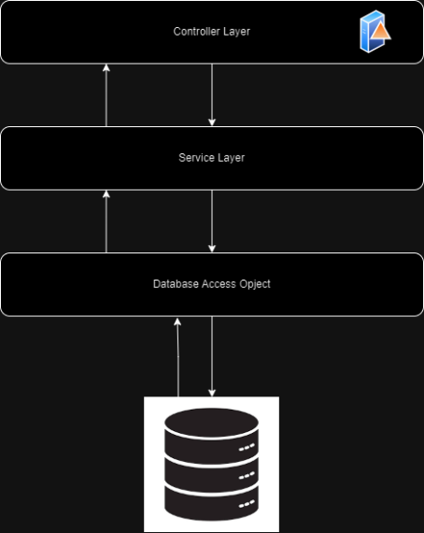

# Data Design

Detailed descriptions and structures for major entities in the system:

### Category:

**id:** Unique identifier for the category.

**name:** Descriptive name of the category.

**description:** A brief description of what types of products fall under this category.

### Product:

**id:** Unique identifier for the product.

**name:** Name of the product.

**image:** URL or path to the product's image.

**price:** Retail price of the product.

**stock:** Quantity of the product available.

**Category Id:** Foreign key linking to the Category table.

### Admin:

**id:** Unique identifier for the admin.

**name:** Admin's full name.

**image:** URL or path to the admin's image.

**email:** Admin's email address.

### Customer:

**id:** Unique identifier for the customer.

**name:** Customer's full name.

**age:** Customer's age.

**image:** URL or path to the customer's image.

**email:** Customer's email address.

# Interface Design

## API Endpoints:

### Categories:

**GET /categories -** Retrieve all categories.

**POST /categories -** Create a new category.

**PUT /categories/{id} -** Update an existing category.

**DELETE /categories/{id} -** Delete a category.

### Products:

**GET /products -** Retrieve all products.

**GET /products/{id} -** Retrieve a product by ID.

**POST /products -** Create a new product.

**PUT /products/{id} -** Update an existing product.

**DELETE /products/{id} -** Delete a product.

### Admins and Customers:

User authentication and management endpoints.

# Security Design

**Authentication and Authorization:** Implement JWT (JSON Web Tokens) for secure authentication and authorization of users.

**Data Protection:** Use HTTPS for secure data transmission. Encrypt sensitive data in the database.

# User Interface Design

**Mockups and Storyboards:** Include detailed mockups of the user interface for both desktop and mobile views. Provide storyboards showing user interaction and flow through the application.

**Navigation Paths:** Describe typical user journeys, such as searching for a product, adding items to a cart, and checking out.

# Appendices

**Detailed Algorithms:** Provide any complex business logic or algorithms used within the service layer.

**Test Cases:** Outline typical test cases for unit and integration testing of the application.

# Version History

**Document Revisions:** Maintain a log of all changes, dates, and authors involved in the revisions.